Applications and Challenges of MEOR
A Minor Project mid review (PROJ3136) Report

Submitted in partial fulfilment
for the degree of
BACHELOR OF TECHNOLOGY
in
APPLIED PETROLEUM ENGINEERING
By Team No: 04
S. No. | Student Name | Roll No. | SAP ID
1 | Aaman Sarkar | R870222021 | 500105204
2 | Simone Paul | R870222007 | 500102145
3 | Harshit Kumar Singh | R870222036 | 500110028
4 | Rishi Agarwal | R870222023 | 500102132

Under the guidance of

Dr. Mandira Agarwal

Distinguished Professor, UPES


Department of Petroleum Engineering & Earth Sciences, Energy Cluster,
School of Advanced Engineering (SOAE)

UPES, Dehradun-248007
April 2025
End-review Comments
1 | Report submitted by the student on the date | _____ / ____ / 2025
2. | Student has presented on the date | _____ / ____ / 2025
3. | Is the plagiarism below 15 % with word count less than 4? | Tick (Yes / No)
4. | Comments to the student (s) (if any):

Signature of panel member 1 Signature of panel member 2
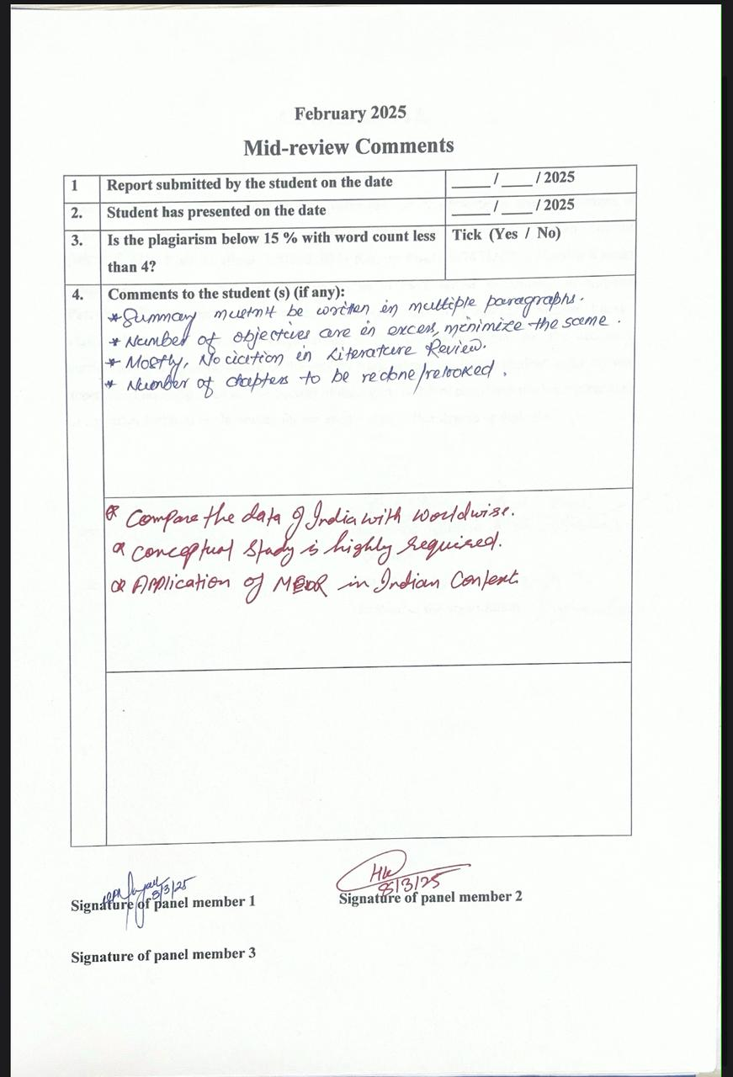

CERTIFICATE

This is to certify that the minor project report entitled “Applications and Challenges of MEOR – Modelling Approach” submitted by Team member Aaman Sarkar (R870222021), Rishi Agarwal (R870222023), Simone Paul (R870222007), Harshit Kumar Singh (R8702220) for the award of the degree of Bachelor of Technology in Applied Petroleum Engineering at Department of Petroleum Engineering and Earth Science, Energy cluster, School of Advanced Engineering, UPES, Dehradun, India, for the academic curriculum, is a bonafide record of the Project work carried out by the student under my/our supervision (s) and guidance. The content of the report, in full or parts have not been submitted to any other Institute or University for the award of any other degree or diploma.

Date: |  | Name and signature of the supervisor/c0-supervisor (s)
Place: |  | Name of the organization
 |  | Location of the organization

DECLARATION BY THE STUDENTS
We hereby declare that the Minor Project report submitted to Department of Petroleum Engineering and Earth Science, Energy cluster, School of Advanced Engineering, UPES, Dehradun, by us, contains the record/results of the work that was purely carried out by me/us during my Minor project at UPES, Dehradun, India under the mentorship of Dr. Mandira Agarwal. It does not contain any material that was previously published or written by another person as well as any material which has been accepted and submitted for the award of any other Degree or Diploma to any other University or Institute.

Date:
Place:

Name and signature of all students (Full roll number)

Aaman Sarkar (R870222021)

Simone Paul (R870222007)

Harshit Kumar Singh (R870222036)

Rishi Agarwal (R870222023)

Energy Cluster
School of Advanced Engineering
UPES
Dehradun-248007

ACKNOWLEDGEMENTS

We are profoundly grateful to Dr. Mandira Agarwal, Energy Cluster, UPES, Dehradun, for her invaluable guidance, insightful feedback, and thoughtful suggestions throughout this project. We also sincerely appreciate our friends for their patience and support in helping us successfully complete this endeavor.

Date:
Place:

Aaman Sarkar (500105204)
Simone Paul (500102145)
Harshit Kumar Singh (500110028)
Rishi Agarwal (500102132)

Energy Cluster
School of Advanced Engineering
UPES
Dehradun-248007

TABLE OF CONTENTS

Certificate i

Acknowledgment iii

Contents iv

List of tables v

List of figures vi

CHAPTER No. TITLE PAGE-NO

- Introduction 11 – 13
- Literature Review 14 – 22
- Cost Benefit Analysis of MEOR 23 – 26
- Methodology 27 – 29
- Case Study of China & Kazakhstan 30 – 31
- India Case Study 32 – 34
- Environmental Aspects 35 – 39
- Conclusion 40 – 48
- References 49

LIST OF TABLES

Table No Table Title Page No

1. Comparison of Carbonate vs Sandstone Reservoir for MEOR 17
2. Comparison of Carbonate vs Sandstone Reservoir for MEOR 24

3. Nutrient requirements and Growth parameter 25

4. Oil Recovery Factors for Sandstone vs Carbonate Reservoirs 26

5. Cost comparison with other EOR method 29
6. Results and Performance Evaluation 31
7. Results and Performance Evaluation 33
8. Comparative Analysis: Sandstone vs Carbonate Reservoirs 38

SUMMARY

This report explores Microbial Enhanced Oil Recovery (MEOR) as a sustainable and cost-effective alternative to conventional Enhanced Oil Recovery (EOR) methods. The study focuses on the applications, challenges, and economic feasibility of MEOR in sandstone and carbonate reservoirs, analyzing real-world case studies from China (Shengli Oil Field) and Kazakhstan.

The literature review highlights the mechanisms of MEOR, including biosurfactant production, biogas generation, biopolymer formation, bioacid production, and selective plugging. The effectiveness of MEOR largely depends on reservoir rock properties such as porosity, permeability, wettability, and salinity.

In sandstone reservoirs, MEOR has been successful due to high permeability, easier microbial transport, and favorable wettability conditions, leading to 10-20% additional oil recovery. In carbonate reservoirs, MEOR effectiveness is lower (5-15% additional recovery) due to low permeability and oil-wet conditions, but bioacids and wettability alteration techniques help improve results.

The China case study (Shengli Oil Field) showed a 167% increase in oil production and a 12% reduction in water cut after MEOR application. The Kazakhstan case study demonstrated a 120% increase in oil recovery, proving MEOR’s potential in carbonate formations.

The cost-benefit analysis indicates that MEOR is cheaper than chemical and thermal EOR, costing $2-7 per barrel, with low environmental impact. However, challenges such as biofouling, microbial unpredictability, and H₂S production require careful nutrient control and monitoring.

The report concludes that MEOR is a promising, eco-friendly solution for extending oil field life. Future advancements in genetically engineered microbes and AI-driven monitoring could further enhance MEOR’s efficiency and global adoption

CHAPTER 1
INTRODUCTION

What is EOR?

Enhanced Oil Recovery (EOR) is a set of advanced techniques used to extract additional oil from reservoirs beyond what is recoverable through primary (natural pressure) and secondary (water or gas injection) methods. EOR improves oil recovery by altering the physical or chemical properties of the reservoir fluids or rock to mobilize trapped oil. The three main EOR methods include thermal EOR (using heat, such as steam injection, to reduce oil viscosity), chemical EOR (injecting polymers, surfactants, or alkaline solutions to improve oil flow), and gas EOR (using CO₂, nitrogen, or methane to displace oil and maintain pressure).

What is MEOR?

Microbial Enhanced Oil Recovery (MEOR) is a biotechnology-based method used to extract additional oil from reservoirs by utilizing microorganisms. These microbes, often bacteria or archaea, are introduced into the reservoir (or stimulated if they are already present) to alter the oil's physical and chemical properties, making it easier to extract.

Importance of Reservoir Rock type in MEOR effectiveness

The reservoir rock type plays a critical role in the effectiveness of Microbial Enhanced Oil Recovery (MEOR) because it determines microbial transport, nutrient diffusion, and oil displacement efficiency. The key factors influenced by reservoir rock type include porosity, permeability, wettability, and mineral composition, all of which impact microbial activity and metabolite interactions with trapped oil.

Porosity and Permeability

High-porosity rocks (e.g., sandstone) provide more space for microbial growth and movement, increasing MEOR effectiveness.

Low-porosity rocks (e.g., tight carbonate formations) may restrict microbial transport and nutrient penetration, reducing efficiency.

Permeability influences microbial distribution—high-permeability rocks allow better microbial migration, whereas low-permeability formations may trap microbes and limit their impact.

Wettability and Oil Adhesion

Oil-wet reservoirs (common in carbonate rocks) require more aggressive bio-surfactant activity to alter wettability and release trapped oil.

MEOR works best in water-wet or mixed-wet reservoirs, where bio-surfactants can reduce interfacial tension and improve oil mobility.

Rock Composition and Microbial Interaction

Carbonate reservoirs (limestone, dolomite) contain calcium and magnesium, which can react with microbial metabolites, sometimes forming precipitates that clog pores.

Sandstone reservoirs, composed mainly of quartz, are more chemically stable and allow better microbial propagation.

Clay-rich formations can absorb bio-surfactants, reducing MEOR efficiency by limiting the mobility of microbial byproducts.

Rock Heterogeneity and Fluid Flow Paths

Highly fractured reservoirs (carbonate reservoirs) can lead to uneven microbial distribution, where microbes preferentially move through fractures rather than into oil-rich zones.

Homogeneous formations (Sandstone reservoirs) allow better control over microbial placement and nutrient injection, improving MEOR success.

Objective of the study
- Identify and classify the various applications of MEOR in different reservoir types.

Analyze the mechanisms by which MEOR enhances oil recovery.
- Examine the economic feasibility of MEOR compared to other enhanced oil recovery techniques.

CHAPTER 2

LITERATURE REVIEW

2.1 Fundamentals of MEOR

2.1.1 Introduction on MEOR
- MEOR is a tertiary oil recovery technique that utilizes microbes to improve oil displacement, increase permeability, and reduce residual oil saturation.
- It is an alternative to chemical and thermal EOR methods, offering cost-effectiveness and environmental benefits.
    - Mechanisms of MEOR
Microorganisms contribute to oil recovery through various mechanisms:
- Bio-surfactant Production: Reduces interfacial tension between oil and water, enhancing mobility.
- Bio-gas Generation: CO₂, H₂, and CH₄ production help in reservoir pressurization and oil displacement.
- Biopolymer Production: Alters viscosity of injected water to improve sweep efficiency.
- Selective Plugging: Bacterial biomass plugs high-permeability zones, redirecting water flow to unswept areas.
- Bio-acid Production: Microbial acids dissolve carbonate formations and enhance porosity.
- Microbial Degradation of Heavy Oil: Some microbes break down long-chain hydrocarbons, reducing oil viscosity.
    - Synopsis of the MEOR process:
- Microbial Injection: Indigenous or engineered microorganisms are injected into the oil reservoir to interact with the remaining oil after conventional recovery methods (primary and secondary) have been exhausted.
- Microbial Metabolic Products:
  - Biosurfactants: These reduce the interfacial tension between oil and water, decreasing oil viscosity and improving mobility.
  - Biopolymers: These help control the viscosity of the injected fluids, improving sweep efficiency by altering fluid dynamics and reducing permeability in water-swept areas.
  - Biogases: Gases like CO2 and CH4 are produced, which increase reservoir pressure and reduce the oil's viscosity, facilitating its flow.
  - Biomass: Microbial cells proliferate and form biofilms that plug high-permeability zones, redirecting water flow to oil-rich areas, improving oil displacement.
  - Bioacids and Biosolvents: These degrade heavy hydrocarbons and improve oil flow by reducing viscosity and breaking down complex molecules.
- Mechanism of Action:
  - The microbial products alter the properties of the oil and reservoir rock, enhancing the movement of trapped oil.
  - Selective plugging by microbial biomass helps redistribute water to low-permeability regions, improving oil recovery efficiency.
  - Improved Reservoir Dynamics:
  - The microbial action enhances both microscopic and macroscopic sweep efficiency by improving oil mobility and optimizing oil-water interface properties.
  - This leads to more efficient displacement of oil in areas typically difficult to reach with conventional methods.
- Outcome:
  - MEOR improves the recovery of trapped oil, especially in depleted and marginal reservoirs.
  - It offers an eco-friendly, cost-effective alternative to other enhanced oil recovery (EOR) techniques.
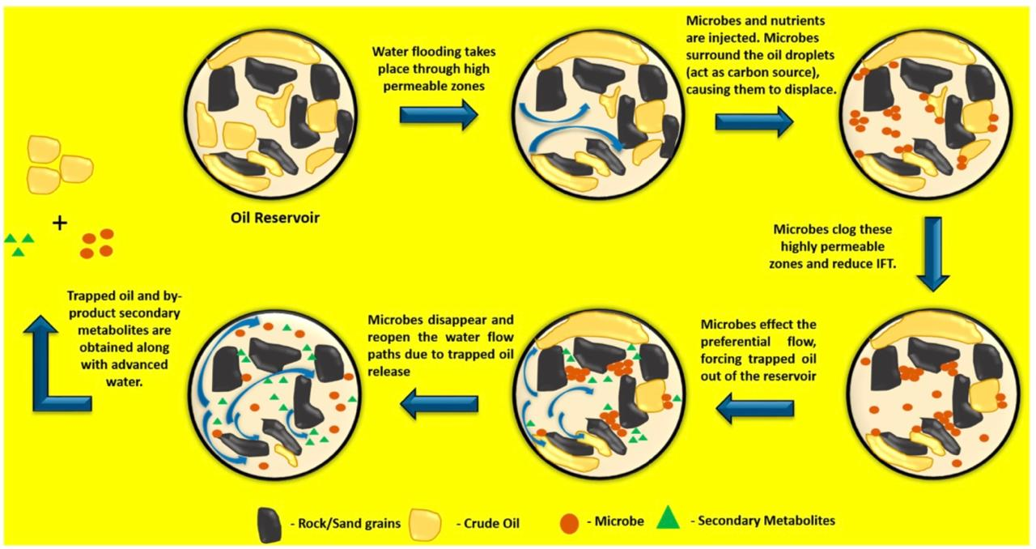
Figure 1https://images.app.goo.gl/aFcghJrWc2tSN1BU7

    - Microorganisms used in MEOR
- Indigenous Microbes: Naturally present in reservoirs and stimulated using nutrients.
- Exogenous Microbes: Specially cultured microbes injected into reservoirs.
Common microbial strains include:
- Bacillus (bio-surfactants)
- Clostridium (bio-gas production)
- Pseudomonas (bio-surfactants and biopolymers)
- Methanogens (methane production)
    - MEOR Implementation Strategies
- Microbial Flooding: Injection of microbes, nutrients, and water to enhance recovery.
- Huff-n-Puff Method: Microbes are injected and left to metabolize before production resumes.
- Water Alternating Microbes (WAM): Alternating injection of microbes and water to improve oil mobility.
Microbial Metabolic Pathways Involved:
- Introduction to Metabolic Pathways:
  - Microbes in MEOR degrade hydrocarbons through two primary metabolic pathways: aerobic and anaerobicpathways.
  - The pathway chosen depends on the reservoir's conditions, such as the availability of oxygen and other electron acceptors.
- Aerobic Metabolic Pathways:
  - Oxygen as Electron Acceptor: In aerobic conditions, oxygen is used as the electron acceptor in the degradation process.
  - Initial Hydrocarbon Breakdown: Microbes such as Pseudomonas putida use monooxygenase and dioxygenase enzymes to attack the hydrocarbons, leading to the oxidation of alkanes and the formation of intermediate metabolites.
  - Conversion of Metabolites: These intermediate products (such as alkanols and alkanals) are further processed by enzymes like alcohol dehydrogenase and aldehyde dehydrogenase to form fatty acids.
  - Final Products: Ultimately, these fatty acids are converted into acetyl-CoA, which feeds into the citric acid cycle, and the final products are CO2 and water.
  - Faster and Efficient: Aerobic degradation is faster and more efficient because it uses less energy compared to anaerobic processes.
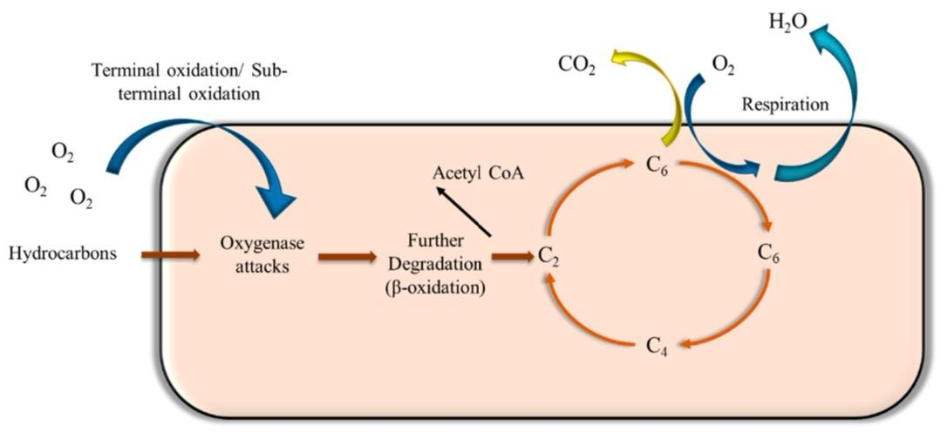
Figure 2https://images.app.goo.gl/aFcghJrWc2tSN1BU7

- Anaerobic Metabolic Pathways:
  - Alternative Electron Acceptors: In anaerobic conditions (where oxygen is absent), microbes use electron acceptors such as nitrate or sulfate.
  - Hydrocarbon Activation: In this pathway, carboxylation and fumarate addition are the primary mechanisms for activating hydrocarbons, particularly aromatic compounds.
  - Formation of Metabolites: The activation process leads to the formation of long-chain fatty acids, which are then metabolized to simpler compounds such as methane (CH4) and carbon dioxide (CO2).
  - Methanogenesis: Methanogenic microbes, such as Methanobacterium, are important in anaerobic pathways, as they produce methane from hydrocarbons, helping to increase the reservoir pressure and enhance oil flow.
  - Slower Process: Anaerobic degradation is typically slower and less energy-efficient compared to aerobic processes but is effective in environments where oxygen is unavailable.
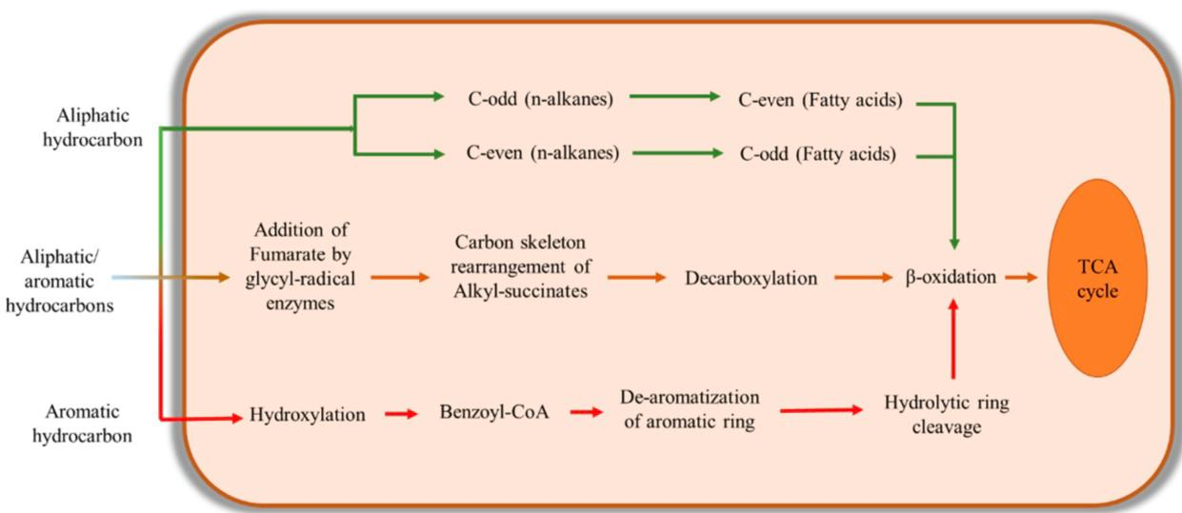
Figure 3https://images.app.goo.gl/ThmeavXqrDNKTMUj7

- Enzymes and Biochemical Reactions:
  - Key Enzymes: Both aerobic and anaerobic pathways rely on specific enzymes to break down hydrocarbons. These include:
    - Monooxygenases and Dioxygenases: For the breakdown of alkanes and aromatic compounds.
    - Peroxidases and Reductases: Involved in the reduction of hydrocarbons and modification of intermediate metabolites.
    - Aldehyde Dehydrogenases: Involved in converting aldehydes into fatty acids.
  - Complex Biochemical Mechanisms: The microbes use a series of biochemical reactions like oxidation, reduction, hydroxylation, and dehydrogenation to degrade hydrocarbons and produce metabolites that enhance oil recovery.

- Methanogenesis and Its Role:
  - Gas-Producing Microbes: Anaerobic microbes like Clostridium and Methanobacterium produce methane (CH4) and carbon dioxide (CO2) during hydrocarbon degradation.
  - Role in Oil Mobilization: These gases increase pressure in the reservoir, reduce the oil’s viscosity, and assist in separating the oil from water and gas phases, making oil flow more easily to production wells.
- Hybrid Pathways:
  - Flexibility for Oxygen Availability: Some microbes use hybrid pathways that combine aerobic and anaerobic mechanisms, allowing them to adapt quickly to fluctuating oxygen levels in the reservoir.
  - This flexibility helps microbes maintain their activity in dynamic reservoir environments.
2. Selecting the Reservoir for MEOR
Key Factors in Reservoir Selection
The successful application of MEOR depends significantly on the characteristics of the oil reservoir. Here are the primary factors involved in selecting a suitable reservoir:
- Permeability:
  - High permeability is crucial for ensuring that the injected fluids (water, microbes, nutrients) can easily flow through the reservoir. Reservoirs with low permeability may require special strategies, such as selective plugging, to enhance oil recovery.
- Geological Complexity:
  - Geological factors like salinity, porosity, temperature, and rock composition (e.g., carbonate vs. sandstone) significantly affect microbial activity. For instance, microbial strains that work well in a carbonate reservoir might not perform as effectively in a sandstone reservoir due to differences in mineral composition and pore structure.
- Wettability:
  - Reservoir wettability (whether the rock is oil-wet or water-wet) affects how well microbes can alter the surface tension between oil and water. In oil-wet reservoirs, bio-surfactants produced by microbes can help change the wettability, improving oil displacement.
- Reservoir Depth and Temperature:
  - The depth of the reservoir affects the temperature and pressure, which in turn influence microbial survival. High-temperature or high-pressure reservoirs may require extremophilic microbes (e.g., thermophilic, halophilic) that are adapted to such harsh conditions.
- Salinity and pH:
  - Microbial growth can be inhibited by high salinity or extreme pH levels, which are common in many oil reservoirs. Microbial strains used in MEOR need to be tolerant of these harsh conditions, or adjustments to the reservoir's environment may be necessary.
Challenges in Reservoir Selection
- Microbial Transport: In heterogeneous reservoirs, the transport of microbes can be uneven, leading to less effective treatment.
- Microbial Growth: The nutrient conditions and the reservoir environment must support the growth of the injected microbes for MEOR to be effective.
2.2 Characteristics of Carbonate and Sandstone Reservoirs
Carbonate Reservoirs
Carbonate reservoirs, mainly composed of limestone (CaCO₃) and dolomite (CaMg(CO₃)₂), hold approximately 60% of the world's oil reserves.

Characteristics:
- Mineralogy: Mostly calcite, dolomite, and some aragonite.
- Porosity: Highly variable (intercrystalline, vuggy, moldic, fracture-related).
- Permeability: Low to moderate, but fractures can significantly enhance permeability.
- Heterogeneity: Highly heterogeneous due to diagenetic processes (e.g., dissolution, recrystallization).
- Pore Structure: Complex, with interparticle, vuggy, and fracture porosity.
- Wettability: Typically oil-wet or mixed-wet, affecting oil recovery efficiency.
- Reservoir Quality: Strongly influenced by diagenesis, leading to unpredictable permeability and porosity.
- Depositional Environment: Mostly marine environments, including reefs, shallow shelves, and deep basins.
- Challenges in Production:
  - High heterogeneity makes reservoir modeling difficult.
  - Fractured systems may lead to rapid water breakthrough.
  - Acid stimulation is often required to improve permeability.

Sandstone Reservoirs
Sandstone reservoirs, composed mainly of quartz (SiO₂) and feldspar, account for about 30-40% of global oil reserves.

Characteristics:
- Mineralogy: Primarily quartz, with feldspar and clays.
- Porosity: Generally higher than carbonate reservoirs (10-30%), mostly intergranular.
- Permeability: Ranges from low to high, depending on grain sorting and cementation.
- Heterogeneity: More uniform than carbonates but can vary due to depositional facies.
- Pore Structure: Predominantly intergranular, leading to predictable flow behavior.
- Wettability: Mostly water-wet, which improves oil displacement efficiency.
- Reservoir Quality: Depends on grain size, sorting, cementation, and compaction.
- Depositional Environment: Fluvial, deltaic, marine, and aeolian environments.
- Challenges in Production:
  - Sand production issues in unconsolidated formations.
  - Water coning and fines migration may reduce permeability.
  - Clay swelling can reduce permeability when in contact with certain fluids.

Comparison study of Carbonate and Sandstone Reservoirs
Type of Reservoir | Carbonate Reservoir  (Kazakhstan Reservoir) | Sandstone Reservoir (China & India Reservoir)
Composition | Limestone, dolomite, calcite | Quartz, feldspar, clays
Porosity | Variable, vuggy and fractured | Higher, intergranular
Permeability | Low to moderate (fracture dependent) | Moderate to high (grain-controlled)
Heterogeneity | Highly heterogeneous | More uniform but varies
Wettability | Oil-wet or mixed wet | Water wet
Pore Structure | Complex (vuggy, inter-crystalline fractures) | Simple (intergranular)
Reservoir Quality | Strongly influenced by diagenesis | Controlled by deposition and compaction
Production Issues | Fracture flow, acid stimulation needed | Sand production,  fines migration

2.3 Microbial Mechanisms in Oil Recovery
2.3.1 Bio-surfactant Production
- Mechanism: Certain microbes produce bio-surfactants, which reduce the interfacial tension (IFT) between oil and water, increasing oil mobility.
- Effect:
  - Enhances oil emulsification, making it easier to flow.
  - Improves oil displacement from reservoir rock surfaces.
  - Alters rock wettability from oil-wet to water-wet, increasing recovery.
- Microbes Involved: Bacillus spp., Pseudomonas aeruginosa, Acinetobacter spp.
- Types of Biosurfactants:
  - Glycolipids (e.g., rhamnolipids, sophorolipids)
  - Lipopeptides (e.g., surfactin)
  - Fatty acids and phospholipids
2.3.2 Biogas Formation
- Mechanism: Anaerobic microbes produce gases (CO₂, CH₄, H₂) through fermentation and methanogenesis.
- Effect:
  - Increases reservoir pressure, enhancing oil displacement.
  - Swells crude oil, reducing viscosity and making it more mobile.
  - Pushes oil towards production wells in a gas drive mechanism.
- Microbes Involved: Clostridium spp., Methanobacterium spp., Desulfovibrio spp.
- Produced Gases:
  - Carbon dioxide (CO₂) – helps in miscible flooding.
  - Methane (CH₄) – reduces oil viscosity.
  - Hydrogen (H₂) – can react with sulfur compounds, reducing oil souring.
2.3.3 Biomass Plugging
- Mechanism: Microbial growth and exopolymer production clog high-permeability zones.
- Effect:
  - Redirects injected water into unswept areas of the reservoir.
  - Improves sweep efficiency by forcing water into low-permeability zones.
- Microbes Involved: Leuconostoc spp., Bacillus spp., Xanthomonas campestris
- Byproducts:
  - Extracellular polymeric substances (EPS)
  - Biopolymers like xanthan gum and dextran
2.3.4 Biopolymer Production
- Mechanism: Certain microbes secrete biopolymers that increase the viscosity of injected water.
- Effect:
  - Improves the mobility ratio between water and oil, reducing fingering.
  - Enhances water flooding efficiency.
- Microbes Involved: Xanthomonas campestris, Leuconostoc mesenteroides, Bacillus spp.
- Common Biopolymers:
  - Xanthan gum
  - Dextran
  - Alginate
2.3.5 Bio-acid Production
- Mechanism: Microbes generate organic acids (e.g., acetic acid, lactic acid) that dissolve carbonate formations, enhancing porosity and permeability.
- Effect:
  - Improves flow paths for trapped oil.
  - Reduces mineral scale formation in reservoirs.
- Microbes Involved: Clostridium spp., Acetobacter spp., Lactobacillus spp.
2.3.6 Microbial Degradation of Heavy Oil
- Mechanism: Certain microbes break down long-chain hydrocarbons into lighter, more fluid components.
- Effect:
  - Reduces oil viscosity, improving mobility.
  - Enhances the recovery of heavy oil and bitumen.
- Microbes Involved: Pseudomonas spp., Bacillus spp., Rhodococcus spp.
- Byproducts:
  - Short-chain hydrocarbons
  - Bio-surfactants
  - CO₂ and H₂ gases
Mechanism | Effect on Oil Recovery | Key Microbes
Bio-Surfactant Production | Lowers interfacial tension, improves oil mobility | Bacillus spp., Pseudomonas spp.
Biogas Formation | Increases pressure, reduces viscosity | Clostridium spp., Methanobacterium spp.
Biomass Plugging | Blocks high-permeability zones, redirects water | Leuconostoc spp., Bacillus spp.
Biopolymer Production | Enhances water viscosity, improves sweep efficiency | Xanthomonas spp., Bacillus spp.
Bio-acid Production | Enhances porosity and permeability | Clostridium spp., Acetobacter spp.
Microbial Degradation | Breaks down heavy oil, reducing viscosity | Pseudomonas spp., Rhodococcus sp

2.4 Previous studies on MEOR applications in different reservoir types
2.4.1 Sandstone Reservoirs
- Study: Youssef et al. (2009) conducted laboratory experiments using Bacillus species to improve oil recovery in sandstone cores.
- Findings: The microbes produced bio-surfactants and gases that enhanced oil mobility, increasing recovery by up to 20%.
- Field Application: Successful field trials have been reported in the Daqing oilfield in China, where indigenous microbes were stimulated using nutrient injection, leading to a 10-15% increase in oil recovery.
2.4.2 Carbonate Reservoirs
- Study: Al-Wahaibi et al. (2014) investigated MEOR in carbonate reservoirs using indigenous bacterial strains.
- Findings: The microbes altered wettability from oil-wet to water-wet and produced bio-surfactants that reduced interfacial tension, leading to improved oil recovery.
- Field Applications: Trials in Middle Eastern carbonate reservoirs demonstrated incremental oil recovery in mature fields.
- pH Sensitivity: Some microbial processes are pH-sensitive, and carbonate reservoirs often have high pH levels.
2.5 Challenges and limitations of MEOR in different lithologies
2.5.1 Carbonate Reservoirs
- High Heterogeneity: Carbonate reservoirs have complex pore structures, fractures, and vugs, making microbial transport and distribution uneven.
- High Salinity and Alkalinity: Many carbonate formations have high salinity, which can limit microbial growth and activity.
- Low Permeability Zones: Microbes may struggle to penetrate tight rock formations, reducing efficiency.
- pH Sensitivity: Some microbial processes are pH-sensitive, and carbonate reservoirs often have high pH levels.

2.5.2 Sandstone Reservoirs
- Clay Content Issues: Some sandstones contain clays like kaolinite or smectite, which can swell and reduce permeability when microbial metabolites are introduced.
- Permeability Variations: High-permeability streaks can cause microbes and nutrients to bypass lower-permeability zones, leading to inefficient oil recovery.
- Bacterial Transport: The presence of fines migration and clogging may affect bacterial movement and metabolism.

CHAPTER 3
COST BENEFIT ANALYSIS OF MEOR

Microbial Enhanced Oil Recovery (MEOR) is a cost-effective and environmentally friendly alternative to traditional enhanced oil recovery (EOR) methods such as thermal, chemical, and gas injection. The cost-benefit analysis of MEOR depends on the type of microbes used, their metabolic byproducts, reservoir conditions, and the scale of application.

Microbe Type | Primary Function | Cost($/Barrel) | Benefit (%) | Challenges
Bio-surfactant Producing Bacteria (Bacillus subtilis, Pseudomonas aeruginosa) | Reduce interfacial tension, improve oil mobility | $2 - $5 | 15-30% oil recovery increase | Bio-surfactant production is costly at scale
Biopolymer-Producing Bacteria (Xanthomonas campestris, Leuconostoc mesenteroides) | Increase water viscosity for better sweep efficiency | $3 - $6 | 10-20% increase in oil recovery | High viscosity biopolymers can clog pipelines
Gas-Producing Bacteria (Clostridium spp., Methanobacterium spp.) | Increase pressure, reduce oil viscosity | $1 - $4 | 15-25% increase in oil mobility | Gas control is difficult in unpredictable reservoirs
Bioacid-Producing Bacteria (Acetobacter spp., Lactobacillus spp.) | Dissolve carbonate formations, increase permeability | $2 - $5 | 10-15% improved reservoir flow | Excess acid can cause corrosion issues
Plugging Bacteria (Bacillus licheniformis, Enterobacter cloacae) | Block high-permeability zones, redirect water flow | $2 - $4 | 10-20% better oil displacement | Uncontrolled microbial growth may lead to over-plugging
Archaea (Methanobacterium spp., Thermoplasma spp.) | Methane and hydrogen gas production, effective in extreme conditions | $3 - $7 | 10-25% improved recovery in deep reservoirs | Limited field studies on archaea in MEOR
Fungi (Aspergillus niger, Penicillium spp.) | Biosurfactant and bioacid production | $2 - $6 | 5-15% improved oil recovery | Fungi growth is slower than bacteria
Yeasts (Saccharomyces cerevisiae, Candida tropicalis) | Emulsification, CO₂ production | $2 - $5 | 5-10% improved oil mobility | Less effective in deep reservoirs

3. Implementation cost of MEOR
3.1 Upfront Costs
      - Microbial Culturing and Growth Medium – $500,000 - $2,000,000 per project
      - Injection System Setup – $300,000 - $1,000,000
      - Monitoring Equipment and Sensors – $100,000 - $500,000
3.2 Operational Costs
      - Microbial Injection – $2 - $7 per barrel of oil recovered
      - Nutrient Supply (for microbial growth) – $100,000 - $500,000 per year
      - Well Treatment and Maintenance – $50,000 - $300,000 per well

3.3 Cost comparison with other EOR methods
EOR Method | Oil Recovery Efficiency (%) | Cost ($/Barrel) | Environmental Impact
Thermal EOR (Steam Injection) | 40-60% | $10 - $30 | High (CO₂ emissions)
Chemical EOR (Polymer/Surfactant Injection) | 30-50% | $8 - $25 | Medium (chemical waste)
Gas Injection (CO₂, N₂, CH₄) | 20-40% | $5 - $20 | Medium (depends on gas type)
MEOR (All Microbial Types) | 10-30% | $2 - $7 | Low (biodegradable, sustainable)

CHAPTER 4
METHODOLOGY

4.1 Description of Carbonate and Sandstone Reservoir
The effectiveness of Microbial Enhanced Oil Recovery (MEOR) is highly influenced by the reservoir rock type, with carbonate and sandstone reservoirs being the two most common types. These rock formations differ in porosity, permeability, wettability, and microbial interactions, which impact the success of MEOR.
4.1.1 Sandstone Reservoir and MEOR
Characteristics of Sandstone Reservoirs
- Composition: Mainly composed of quartz with some feldspar and clays.
- Porosity: Moderate to high (15-30%), allowing better microbial transport.
- Permeability: Moderate to high (10-1000 mD), enabling easier microbial migration and metabolite diffusion.
- Wettability: Usually water-wet, meaning oil does not strongly adhere to rock surfaces.
Impact on MEOR
- Favorable for Microbial Growth and Transport – Sandstone’s high porosity and permeability allow microbes and nutrients to spread effectively.
- Bio-surfactants Work Efficiently – Since sandstone is often water-wet, bio-surfactants can easily reduce interfacial tension, mobilizing oil.
- Lower Risk of Microbial Blockage – Fewer carbonate precipitates reduce the risk of pore clogging during microbial activity.
- Potential Challenges: Some sandstones contain clay minerals, which can adsorb bio-surfactants and reduce MEOR efficiency.
- Overall: Sandstone reservoirs are highly suitable for MEOR due to their better microbial mobility, nutrient distribution, and oil displacement potential.

4.1.2 Carbonate Reservoirs and MEOR
Characteristics of Carbonate Reservoir
- Composition: Mainly limestone (CaCO₃) and dolomite (CaMg(CO₃)₂).
- Porosity: Highly variable (5-25%), with frequent vuggy and fractured porosity.
- Permeability: Generally low (<10 mD), except in fractured carbonates where permeability is high.
- Wettability: Typically oil-wet or mixed-wet, making oil recovery more difficult.
Impact on MEOR
- Selective Plugging in Fractured Carbonates – Some microbes produce biopolymers, which can plug high-permeability fractures, diverting flow to oil-rich zones.
- Bioacid Production Helps Improve Permeability – Certain bacteria produce organic acids (e.g., lactic acid, acetic acid) that dissolve calcium carbonate, creating new flow pathways for oil.
- Biosurfactants Can Modify Wettability – Some biosurfactants alter wettability from oil-wet to water-wet, improving oil release.
- Challenges in MEOR for Carbonates:
  - Low permeability restricts microbial movement.
  - Fractured reservoirs cause uneven microbial distribution.
  - Reactions between microbial acids and carbonate minerals can produce unwanted precipitates, clogging pores.
- Overall: MEOR can be effective in carbonate reservoirs if microbial activity is carefully managed, especially in fractured formations where biopolymer plugging and bioacid production can enhance recovery.

Comparison of Carbonate vs Sandstone Reservoir for MEOR
Feature | Sandstone Reservoir  (China & India) | Carbonate Reservoir  (Kazakhstan)
Porosity | High (15-30%) | Variable (5-25%), often fractured
Permeability | Moderate to high (10-1000 mD) | Low (<10 mD), unless fractured
Wettability | Water-wet (favorable for MEOR) | Oil-wet or mixed-wet (harder for MEOR)
Microbial Transport | Easy (due to high permeability) | Difficult (restricted by low permeability)
MEOR success | High (biosurfactants work efficiently) | Moderate (bioacids can help, but microbial distribution is uneven)
Key challenges | Clay minerals can adsorb biosurfactants | Wettability alteration and pore clogging risks
Best MEOR mechanisms | Biosurfactants and biopolymer production | Bioacid production, wettability alteration, and selective plugging

4.2 Growth Conditions of the microbial strains
4.2.1 Nutrient requirements and Growth parameters
Parameter | Sandstone Reservoir  (China & India) | Carbonate reservoir  (Kazakhstan)
Microbial Transport | Easy (High permeability) | Difficult (low permeability)
Wettability | Water-wet (favors biosurfactants) | Oil-wet (requires wettability alteration)
Best Microbial Activity | Biosurfactants, biopolymers, gas production | Bioacid, wettability alteration, selective plugging
Temperature Range | 40-80°C (mesophiles, moderate thermophiles) | 50-100°C (thermophiles preferred)
pH range | 6.5 - 8.5 (neutral to slightly alkaline) | 6.0 - 9.0 (can be more alkaline)
Salinity Tolerance | 10,000 - 100,000 ppm | 20,000 - 150,000 ppm
Carbon Source | Molasses, crude oil, glycerol | Molasses, crude oil, ethanol
Nitrogen Source | Ammonium nitrate, urea | Ammonium salts, organic nitrogen
Phosphorus Source | Sodium phosphate (NaH₂PO₄) | Potassium phosphate (K₂HPO₄)
Sulfur & Trace Elements | MgSO₄, FeSO₄, NaCl | Ca²⁺, Mg²⁺, Fe²⁺, NaCl
Preferred Microbial Type | Biosurfactant and gas-producing bacteria | Bioacid-producing and wettability-altering bacteria

3.2.2 Oil Recovery Factors for Sandstone vs Carbonate Reservoirs
Reservoir Type | Primary Recovery (%) | Secondary Recovery (Water flooding, %) | MEOR Incremental Recovery (%) | Total Recovery (%)
Sandstone | 10-25% | 25-50% | 10-20% | 35-70%
Carbonate | 5-15% | 15-40% | 5-15% | 20-55%

CHAPTER 5
Case Study of China and Kazakhstan

Shengli Oil Field, located in eastern China, is one of the largest oil fields in China, producing heavy and mature oil with high water cut and declining production rates. To extend the economic lifespan of the field, Microbial Enhanced Oil Recovery (MEOR) has been implemented as a cost-effective and environmentally friendly solution. The field trials have demonstrated significant improvements in oil recovery through microbial activity, bio surfactant production, and selective plugging.

5.1 Reservoir Characteristics of Shengli Oil Field
- Reservoir Type: Primarily sandstone, with some carbonate formations.
- Porosity: 18-32% (moderate to high).
- Permeability: 50-500 mD (varies across formations).
- Temperature: 40-85°C (suitable for microbial survival).
- Salinity: 10,000-50,000 ppm (moderate, allowing microbial adaptation).
- Oil Properties: High viscosity (heavy oil).
- Water Cut: Over 90% in mature wells, indicating the need for enhanced recovery techniques.
5.2 MEOR Implementation Strategy
5.2.1 Microbial Selection and Injection Method
Microbial Strains Used:
- Bacillus subtilis (biosurfactant production, oil mobilization).
- Pseudomonas aeruginosa (reduces interfacial tension, enhances emulsification).
- Clostridiumm spp. (gas production, increasing reservoir pressure).
5.2.2 Nutrient Injection
- Carbon source: Molasses and crude oil.
- Nitrogen Source: Ammonium nitrate.
- Phosphorus Source: Sodium Phosphate.
5.2.3 MEOR Application Process
- Huff and Puff Method:
  - Microbial solution is injected into wells.
  - The well is shut for 7-14 days to allow microbial growth.
  - Oil production is measured after re-opening.
- Microbial Flooding Method:
  - Continuous injection of microbial solution and nutrient to stimulate indigenous microbes in the reservoir,
  - This enhances bio-surfactant and gas production, displacing trapped oil.
  - Results and Performance Evaluation
Parameter | Before MEOR | After MEOR | Improvement
Oil Production Rate | 8.9 tons/day | 23.8 tons/day | 167% increase
Water Cut | 92% | 80% | Reduced by 12%
Interfacial Tension (IFT) | High | Reduced by 75% | Improved oil mobility
Cumulative Additional Oil Recovery | - | 2700 tons | Significant increase

5.4 Challenges and Limitations
- Heterogeneous Reservoir Conditions: Microbial activity was inconsistent across different permeability zones.
- High Water Cut Wells Required Multiple Cycles: Some wells needed repeated MEOR injections to maintain production rates.
- Limited Microbial Growth in High Salinity Zones: Adjustments to nutrient composition were needed.

Kazakhstan is one of the world's major oil-producing countries, with significant oil reserves located mainly in the Atyrau, Mangystau, and Aktobe regions. The country relies on oil production as a major economic driver, producing 1.814 million barrels per day in 2018. However, many of Kazakhstan’s oil fields face challenges such as high oil viscosity, low permeability, and reservoir heterogeneity, making conventional extraction methods inefficient. To address these issues, researchers have explored Microbial Enhanced Oil Recovery (MEOR) as a cost-effective and environmentally friendly alternative to traditional Enhanced Oil Recovery (EOR) techniques
5.5 Reservoir Characteristics of Kazakhstan Oil Field
- Reservoir Type: Primarily carbonate reservoirs (North Caspian Basin) with some sandstone formations.
- Porosity: Low to moderate (5-25% in carbonates, 15-30% in sandstones).
- Permeability: Generally low (<10 mD in carbonates), affecting fluid flow.
- Temperature: Varies between 40-100°C, requiring thermophilic microbes.
- Salinity: High (20,000-150,000 ppm), necessitating halophilic microbial strains.
- Oil Characteristics: High viscosity, high paraffin and asphaltene content, requiring viscosity-reducing MEOR techniques.
5.6 MEOR Implementation Strategy in Kazakhstan
5.6.1 Microbial Selection and Injection Process
Researchers selected indigenous and exogenous microbes capable of producing:
- Biosurfactants (Bacillus subtilis, Pseudomonas aeruginosa) – Reduce oil viscosity and interfacial tension.
- Bioacids (Clostridium spp., Enterobacter spp.) – Improve permeability by dissolving carbonate rocks.
- Gas-Producing Bacteria (Methanobacterium spp.) – Increase reservoir pressure and enhance oil displacement.
5.6.2 MEOR Application Methods
- Huff-and-Puff Method – Microbial solutions were injected into wells, shut for 7-14 days, then re-opened to measure oil production improvements.
- Microbial Flooding – Continuous injection of microbial and nutrient solutions into reservoirs to stimulate indigenous microbial activity.

5.7 Results and Performance Evaluation
Parameter | Before MEOR | After MEOR | Improvement
Oil Production Rate | 10 tons/day | 22 tons/day | 120% increase
Water Cut | 85% | 72% | Reduced by 13%
Interfacial Tension (IFT) | High | Reduced by 70% | Improved oil mobility
Cumulative Additional Oil Recovery | - | 3000+ tons | Significant increase

5.8 Challenges and Limitations
- High Salinity and Temperature – Some microbes struggled to survive in Kazakhstan’s extreme reservoir conditions.
- Reservoir Heterogeneity – Uneven microbial distribution in fractured carbonate reservoirs required adjustments in injection techniques.
- Multiple Injection Cycles Required – Some wells needed repeated MEOR treatments to maintain production increases.

Comparative Analysis of Oil Recovery Efficiency in Carbonate vs. Sandstone Reservoirs
Kazakhstan: Carbonate-Dominated Reservoirs
Kazakhstan’s oil reservoirs primarily consist of carbonate formations (such as at the Tengiz, Kashagan, and Zhetybai oilfields). These formations present challenges due to low permeability, high asphaltene and resin content, and high oil viscosity.
• Tengiz Field: This giant oilfield has high sulfur content and deep carbonate formations.
- Zhetybai Field: After MEOR treatments, injection capacity increased by six times, improving oil sweep efficiency from 0.37 to 0.46 .
- Despite these improvements, microbial flooding in carbonate rocks is more challenging than in sandstone due to limited porosity and permeability.
China: Sandstone-Dominated Reservoirs
Chinese oilfields such as Daqing, Shengli, and Changqing contain medium to high-permeability sandstone reservoirs, which respond more effectively to MEOR.
• Changqing Oilfield (Ma-ling Block): MEOR was applied in 27 wells with permeability ranging from 2 to 149 mD. This led to an 18% increase in oil production, recovering an extra 2,500 tons of oil.
• Shengli Oilfield (Shan 12 Block): After MEOR was applied in August 2004, oil production rose from 8.9 tons/day to 23.8 tons/day, with a water-cut reduction from 92% to 80%, leading to 2,700 tons of additional oil.
Thus, sandstone reservoirs generally yield better results in MEOR due to their higher porosity and permeability compared to carbonate reservoirs.

Influence of Rock Wettability and Porosity on Microbial Growth and Oil Mobilization
Kazakhstan: Carbonate Réservoirs
• The oil-wet nature of Kazakhstan’s carbonate rocks makes it difficult for microbial metabolites (e.g., biosurfactants) to spread effectively.
• Bacterial strains like Bacillus subtilis were tested for biosurfactant production, leading to partial wettability alteration towards water-wet conditions.
• In Zhetybai Field, MEOR helped increase the effectiveness of injection by altering the pore structure, but the improvement was marginal compared to sandstone formations.

China: Sandstone Reservoirs
• Sandstone formations in Daqing and Shengli oilfields had better responses to MEOR due to naturally higher permeability and easier microbial transport.
• In Daqing Oilfield (Chao 50 block), microbial flooding increased oil recovery by 3% OOIP, with an effective duration of 3 years.
These results suggest that rock wettability and porosity significantly impact MEOR efficiency, with sandstone reservoirs providing better results.
Effectiveness of Biosurfactants and Biogas in Different Rock Types
Kazakhstan
• MEOR at the Zhanatalap and Chinarevo fields tested Pseudomonas aeruginosa strains capable of producing biosurfactants and acids.
• Biosurfactants reduced interfacial tension (IFT) significantly, but their effectiveness in carbonates was limited due to poor pore connectivity.
• Biogas production (CO₂ and CH₄) in the Akingen oilfield led to an increase in reservoir pressure, aiding heavy oil mobilization.
China
• Biosurfactants were more effective in sandstone formations, where microbial metabolites easily permeated pore spaces.
• In Dagang Oilfield, biogas production helped lower oil viscosity, resulting in an additional 8,700 tons of recovered oil .
Thus, biosurfactants work more effectively in high-permeability sandstone reservoirs, whereas biogas methods show promise in heavy oil carbonate fields.

CHAPTER - 6
India's MEOR Case Study –
ONGC Ahmedabad & Assam Assets
  - Objective
The aim was to enhance oil recovery from depleted reservoirs in the Ahmedabad and Assam Assets operated by Oil and Natural Gas Corporation (ONGC) using Microbial Enhanced Oil Recovery (MEOR). This technique was designed to recover residual oil left after the conventional methods (primary and secondary) were exhausted.
  - Technology and Method
A microbial consortium composed of thermophilic bacteria capable of surviving high temperature (up to 90°C), high pressure, and moderate salinity was developed. This consortium was designed to produce essential microbial by-products, including biosurfactants, biogases, and biopolymers.
  - The Huff & Puff technique was applied, where microbes were injected into the reservoir, and oil production was followed by microbial action and subsequent extraction.
6.3 Microbial Cultivation and Injection:
  - The microorganisms were cultured in anaerobic bioreactors at 90°C. After culturing, they were injected into the selected wells. The microbial agents were left to proliferate for 15–20 days within the reservoirs, where they produced metabolites like biosurfactants (for reducing oil viscosity) and biogases (for pressure build-up).
  - Pilot Testing:
The initial trials were conducted on 15 wells in the Ahmedabad and Mehsana Assets, and later, the technology was expanded to 50 additional wells in Ahmedabad, 9 wells in Assam, and 2 wells in Georgia.
  - Reservoir and Microbe Selection:
  - The microbial strains were selected based on their ability to thrive under extreme conditions of temperature, pressure, and salinity typical of Indian oil fields.
  - Geological complexity and reservoir permeability were key factors for selecting the appropriate microbes. High-permeability zones were targeted for plugging, which helped redirect injected fluids into less permeable areas, improving oil displacement efficiency.
Project Overview:
- Objective: Enhance oil recovery from stripper wells in ONGC's Ahmedabad and Assam Assets using microbial technology.
- Technology Developed: A consortium of thermophilic bacteria capable of surviving temperatures up to 90°C, pressures up to 140 kg/cm², and salinities ranging from 2% to 4%.
- Collaborators: ONGC Institute of Reservoir Studies (IRS), TERI, and OTBL.
- Methodology: The Huff & Puff technique, involving microbial injection and subsequent oil production through the same well.
Implementation Details:
- Initial Trials: Conducted in 15 oil wells across Ahmedabad and Mehsana Assets.
- Expansion: Technology applied to 50 additional wells in Ahmedabad, 9 wells in Assam, and 2 wells in Georgia.
- Microbial Cultivation: Bacteria cultured in anaerobic bioreactors at 90°C, then injected into wells.
- Proliferation Period: Bacteria allowed to proliferate for 15–20 days, producing metabolites such as biosurfactants, biopolymers, fatty acids, and gases.
Outcomes:
- Production Increase: In some wells, daily oil production increased threefold.
- Commercial Success Rate: Approximately 60%.
- Technical Success Rate: Over 80%.
- Patents: Joint patents granted in India, the US, Canada, and Russia.
Technology Details:
- Microbial Consortium: Bacterial consortium S2 developed for enhanced oil recovery.
- Metabolite Production: Microbial metabolites reduce interfacial tension, alter rock wettability, and increase pore throat pressure, facilitating oil mobilization.
- Reservoir Conditions: Designed to function under high temperature, pressure, and salinity conditions typical of Indian oil reservoirs.
Applications:
- Primary Users: ONGC, Oil India Limited (OIL), and other oil-producing companies.
- Service Model: Turnkey solutions provided, including microbial cultivation, injection, and post-injection monitoring.

Additional Information:
- Technology Provider: OTBL, a joint venture between ONGC and TERI, specializing in biotechnical solutions for the oil and gas industry.
- Global Reach: MEOR technology has been successfully implemented in oil fields beyond India, including Georgia.
  - Results:
  - Oil Production Increase: In certain wells, daily oil production increased up to three times compared to the baseline levels.
  - Commercial Success Rate: The commercial success rate was approximately 60%.
  - Technical Success Rate: Over 80% technical success, proving the technique's reliability in different reservoir environments.
  - Patents: The technology has led to the granting of joint patents in India, the U.S., Canada, and Russia for this novel biotechnological approach to enhanced oil recovery.

Parameter | Institute of Reservoir Studies (India)
Location | Ahmedabad, India
Lithology | Sandstone
Depth (ft.) | 8000
Porosity (fraction) | -
Permeability (mD) | Less than 50
Temperature (°F) | 194
Oil Density (API) | 20
Brine Salinity (g/L) | More than 10
pH | 6 to 9
Viscosity (cp) | 20
Residual Oil Saturation (%) | Less than 25
Pressure (psi) | Less than 4267
Water Cut (%) | 30 to 90

CHAPTER 7
ENVIRONMENTAL ASPECTS

Microbial Enhanced Oil Recovery (MEOR) is considered a more environmentally friendly alternative to conventional Enhanced Oil Recovery (EOR) methods, such as chemical and thermal processes. However, the environmental impact of MEOR varies depending on the reservoir type (sandstone vs. carbonate). This case study explores the environmental aspects of MEOR applications in both sandstone and carbonate reservoirs, highlighting benefits, challenges, and mitigation strategies.
7.1 Environmental Benefits in Sandstone Reservoirs
- Reduced Chemical Use- Biosurfactants replaced synthetic surfactants, lowering chemical pollution.
- Lower Energy Consumption- No Steam injection was needed, reducing CO₂ emissions.
- Minimal Groundwater Contamination – Microbial metabolites are biodegradable, reducing contamination risks.
- Lower Water Requirement – Compared to polymer flooding, MEOR used 30% less water, reducing environmental stress.
7.2 Environmental Challenges in Sandstone Reservoirs
- Biofouling in Reservoir Pores – Excessive microbial growth blocked high-permeability zones.
- Uncontrolled Gas Production – Clostridium species generated excess CO₂, leading to pressure buildup.
- Reservoir Heterogeneity – Microbes spread unevenly, requiring additional injections.
7.3 Environmental Benefits of MEOR in Carbonate Reservoirs
- Reduced Acid Injection – Microbial bioacids replaced harmful mineral acids (e.g., HCl), reducing chemical waste.
- Improved Reservoir Permeability – Bioacid reactions enhanced rock porosity, reducing the need for hydraulic fracturing.
- Less Water Contamination – Biodegradable biosurfactants reduced the risk of toxic runoff into water sources.
- Lower CO₂ Emissions – MEOR eliminated the need for thermal methods.
7.4 Environmental Challenges in Carbonate Reservoirs
- Potential for Over-Acidification – Excessive microbial acid production led to reservoir rock dissolution.
- H₂S Gas Production – Some microbial processes generated toxic hydrogen sulfide (H₂S).
- Risk of Microbial Unpredictability – Indigenous microbes reacted differently to nutrient injections, leading to biofouling in fractures.
7.5 Comparative Analysis: Sandstone vs Carbonate Reservoirs
Environmental Aspect | Sandstone Reservoir | Carbonate Reservoir
Chemical Use | Reduced Surfactant use | Reduced acid use
Water Contamination Risk | Low | Moderate(H₂S risk)
Biofouling Risk | Moderate (pore blocking) | High (fracture clogging)
Gas Production | CO₂ buildup (manageable) | H₂S production (toxic)
Energy Efficiency | No steam injection | No acid fracturing
Reservoir Compatibility | High microbial mobility | Limiter due to permeability

CHAPTER 8
CONCLUSION

Microbial Enhanced Oil Recovery (MEOR) has emerged as a cost-effective, sustainable, and environmentally friendly alternative to conventional Enhanced Oil Recovery (EOR) methods. The use of biosurfactant-producing, gas-generating, bioacid-producing, and selective-plugging microbes has been shown to enhance oil recovery in both sandstone and carbonate reservoirs.

8.1 Key Findings:
- MEOR Improves Oil Recovery in Both Sandstone and Carbonate Reservoirs
  - In sandstone reservoirs, MEOR primarily enhances oil mobility through biosurfactants and gas production, leading to an incremental recovery of 10-20%.
  - In carbonate reservoirs, MEOR is effective in modifying wettability and dissolving carbonate formations, increasing oil displacement by 5-15%.
- Environmental Benefits and Challenges
  - MEOR reduces chemical and energy-intensive processes, lowering CO₂ emissions and minimizing groundwater contamination.
  - However, challenges such as biofouling, excessive microbial growth, and potential H₂S production must be managed through controlled nutrient injection and microbial selection.
- Field Applications Show Positive Results
  - MEOR field trials in China’s Shengli Oil Field showed a 167% increase in oil production and a 12% reduction in water cut.
  - In Kazakhstan’s carbonate reservoirs, MEOR demonstrated a 120% increase in oil recovery while replacing conventional acidizing techniques.

- Microbial Selection and Reservoir Suitability are Crucial
  - Sandstone reservoirs favor biosurfactant-producing and gas-producing microbes, allowing better microbial transport and oil mobilization.
  - Carbonate reservoirs require bioacid-producing and wettability-altering bacteria, but careful control of acid production is necessary to prevent excessive rock dissolution.
- Economic and Operational Viability
  - MEOR is cheaper than thermal and chemical EOR, with lower infrastructure modifications required.
  - However, the longer response time (weeks to months) requires continuous optimization and monitoring for effective application.

9.2 Final Thoughts
MEOR presents a promising solution for extending oil field productivity while reducing environmental impact and operational costs. Future advancements in genetically engineered microbes, AI-driven reservoir monitoring, and hybrid EOR approaches could further enhance MEOR’s effectiveness, making it a mainstream technology for sustainable oil recovery.

Références

  - Gao, C. H., & Zekri, A. (2011). “Applications of Microbial-Enhanced Oil Recovery Technology in the Past Decade”. Energy Sources, Part A: Recovery, Utilization, and Environmental Effects, 33(10), 972–989. https://doi.org/10.1080/15567030903330793

  - Kapse, N., Dagar, S.S. & Dhakephalkar, P.K. “Appropriate characterization of reservoir properties and investigation of their effect on microbial enhanced oil recovery through simulated laboratory studies.” Sci Rep 14, 15401 (2024). https://doi.org/10.1038/s41598-024-65728-4.

Rebecca S. Bryant., “Potential Uses of Microorganisms in Petroleum Recovery Technology.” https://ojs.library.okstate.edu/osu/index.php/OAS/article/view/5418/5045#:~:text=There%20are%20three%20ways%20in,oil%20in%20reservoirs%3B%20and%20(c

  - Haicheng She, Debin Kong, Yiqiang Li, Zaiqiang Hu, Hu Guo (2019).
“Recent Advances of Microbial Enhanced Oil Recovery (MEOR) in China.” Geofluids and Energy for the XXI Century (2019).
https://doi.org/10.1155/2019/1871392

5. Quraishi, M.; Bhatia, S.K.; Pandit, S.; Gupta, P.K.; Rangarajan, V.; Lahiri, D.; Varjani, S.; Mehariya, S.; Yang, Y.-H. Exploiting Microbes in the Petroleum Field: Analyzing the Credibility of Microbial Enhanced Oil Recovery (MEOR). Energies 2021, 14, 4684. https://doi.org/10.3390/ en14154684

6. Lazar, I., Petrisor, I. G., & Yen, T. F. (2007). Microbial Enhanced Oil Recovery (MEOR). Petroleum Science and Technology, 25(11), 1353–1366. https://doi.org/10.1080/10916460701287714

7. Yernazarova A, Shaimerdenova U, Akimbekov N, Kaiyrmanova G, Shaken M and Izmailova A (2024) Exploring the use of microbial enhanced oil recovery in Kazakhstan: a review. Front. Microbiol. 15:1394838. doi: 10.3389/fmicb.2024.1394838
8. ONGC TERI biotech limited, “MEOR (Microbial Enhanced Oil Recovery) Technology for application in stripper oil wells”, Institute of Reservoir Studies[online]. Available: https://www.otbl.co.in/Case-Studies-meor.php

